
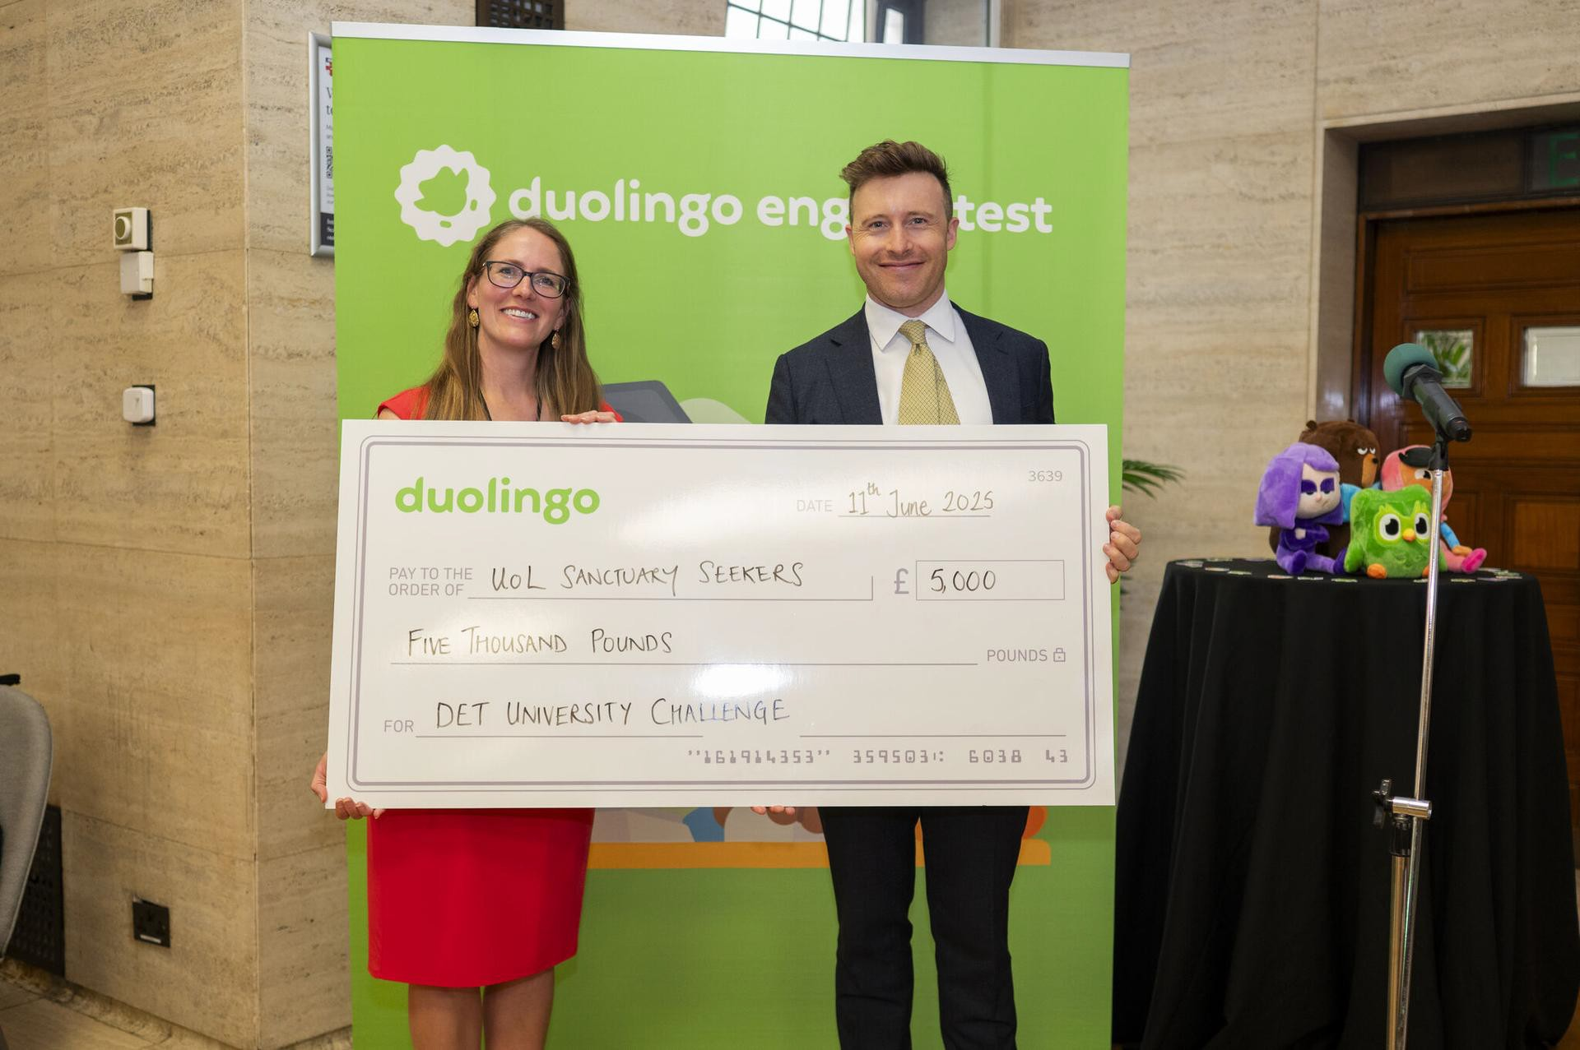






Issue 4
HEURO Global: Managing Mobility Conference, Cardiff, 12-13 August: Booking now open
This two day event at Cardiff Metropolitan University is now open for registration. It has topics of interest to both new and experienced practitioners, and in the first morning includes a Mobility 101 for those new to working in the sector. Dinner on the middle night will be at Cardiff Castle.
The programme will include the following topics:
- COIL and blended intensive (BIP) projects
- EDI: embracing cultural norms in a more inclusive world
- effective crisis management for study abroad
- enabling mobility in STEM subjects
- India as a mobility destination
- leveraging social media for mobility
- personal health and wellbeing
- travel industry support for familiarisation experiences
- Turing Scheme update
- working with TNE partners for short term mobility
Click here for more information and registration.
Fiona Ashmore first winner of Duolingo English Test University Challenge
Dr Fiona Ashmore, University of Leicester and former HEURO Vice Chair, was the winner of the new Duolingo English Test University Challenge, receiving the award at the Duolingo DETcon event in London on 11 June.
‘We launched the challenge to bridge the gap between policy and practice, giving university staff experience of the assessment process their students undertake’ said Michael Lynas, Director, UK and Ireland, Duolingo.
Fiona has chosen to donate the £5,000 prize to the University of Leicester
Sanctuary Seekers Unit. Congratulations Fiona!
HEURO Global Erasmus v Turing Survey
The results of the recently conducted straw poll are attached. They show both the overall result by question plus a table of comments. The survey result is also broken down by nation (England, Scotland and Wales) and by response to Erasmus or Turing.
EAIE Gothenburg, 9-12 September: Early bird reminder
The early bird rate for conference registration will close on 27 June.
HEURO Global will again hold a pre-conference reception (details to follow) and have a stand at the exhibition free to members. The stand number is T01.
Click here for conference and registration information.
Advocacy campaign to resume US student visas launched by US for Success Coalition and NAFSA
Two major US international education organisations have joined forces and launched an advocacy campaign urging Congress demand the US State Department immediately resume the scheduling of visa appointments, it was reported in The PIE on 12 June.
Taith extended until 2028
Taith, the Welsh international exchange programme, was extended until 2028, the Welsh government announced on 3 June. Alongside, Taith has recently adopted a new application process to make it easier for smaller organisations and institutions to apply.
Turing Scheme funding cut by 29% in 2025-26
The Department for Education confirmed on 11 June that the total Turing Scheme budget in 2025-26 will be £78 million, a 29% reduction from £110 million last year. The decision reflects wider financial pressures and the need to make difficult choices across government spending. It is expected
the proportion allocated to higher education will remain around 60%, with cuts top-slicing the total amount available for all applicants across the education sector.
The aims of the Scheme remain unchanged and will prioritise participants from disadvantaged backgrounds and those with special educational needs (SEND) and disabilities.
Providers are being notified of the outcome of their applications, including exact grant amounts, during June.
Click here for the Turing Scheme 2025-26 guidance document on the UK government website.
Erasmus+ reassociation and UK-EU youth mobility scheme
At the UK-EU summit held in London on 19 May, the UK and EU agreed to work towards a number of initiatives aimed at strengthening bilateral cooperation which included a focus on young people and educational exchange.
This included progressing UK association to the Erasmus+ programme. The Department for Education has reaffirmed its commitment to seeking such an association subject to terms that are fair and mutually beneficial.
This also included developing a balanced youth mobility scheme, now renamed as a ‘youth experience’ scheme. The scheme would allow those aged 18-30 from both the UK and EU to live, work, and study in their respective countries for a limited period. The UK already has similar such schemes with 13 countries, including Australia, Canada, Japan, New Zealand and South Korea, which allow those aged 18-30 or 18-35 to live and work in the UK for up to two years.
EAIE: Creating a positive international student experience, Amsterdam, 16-17 October
This in person course is designed to assist you in recognising the requirements of international and mobility students and determining the necessary measures to enhance their overall experience. It includes best practices to encourage cooperation across departments and administrative offices and in developing the tools to influence decision-makers, change institutional practices and evaluate success.
Click here for more information.

